Central Park to Scarsdale | Armonk to Cross River
Go Do Description | Go Do Description
Exit CP@110th St>RSD>181St.>Cabrini > 190St. > | 0.4 R School St
X Ft. Wash > Overlook >187thst >Bway | 0.4 L @cemetery Cox >Sarles
8.0 R Sherman Ave. | 1.3 BR TRO Sarles (@ High St)
0.6 R 207th St across 207th St Br.> Fordham Rd | 2.0 X Byram Lake Rd to end (L to Mt. Kisco)
0.5 BL Sedgwyck @ TL, top of hill | 1.5 R Rt 172/Bedford Rd. (Dangerous road!!)
0.2 BR TRO Sedgwyck Ave. (@Bailey) | 0.2 QL West Patent
2.3 R Moshulu Pkwy | 1.2 R Broad Brook (hardpack)
1.3 R after Bainbridge Ave | (L/R for Bedford Center Metro North Stn.)
0.1 L E. Moshulu Pkwy S. | 0.6 X Rt684
0.1 L Webster Ave. | 0.2 BR Bedford Rd (paved)
5.1 X over Bronx River Pkwy (Midland Ave.) | 0.3 L David’s Hill to end
0.0 QL Parkway to end (Bronxville) | 0.9 L Harris
0.5 L Pondfield across Bronx River Pkwy | 1.0 R Beaver Dam Rd (becomes hardpack)
0.1 R Parkview | 1.0 BR Rt22/Jay St. (John Jay Homestead)
0.9 L Scarsdale Rd to end (@Pennsylvania) | 0.4 BL Maple (hardpack) Cross River Reservoir
3.3 R Ardsley/Popham | 1.8 BR over dam (closed? R @Jay R@Rt35)
0.1 QL E. Parkway after xing ovr Pkwy/RR (Scarsdale)
Scarsdale to Armonk | Cross River to Brewster
Go Do Description | Go Do Description
0.3 R Crane | 0.3 X Rt35 onto Holly (hardpack)
0.1 L Fox Meadow > Walworth > Fisher | 0.4 L N. Salem (hardpack)
3.2 BL Bank Street at traffic light > Ferris | 1.0 R Todd (hardpack)
0.5 R Water St after White Plains Metro N. stn garage | 1.9 L Rt121/124 Salem Rd
0.3 L Church to end | 2.2 L Turkey Hill (hardpack) to end (N.Salem)
0.9 L Rt22/N. Broadway | 1.1 R Rt116/Titicus Rd (L for Purdys Metro N,)
0.4 L Rt22 (N. White Plains) | 0.4 L June Rd > N. Salem Rd (Rt55)
0.3 S N Castle Diner continue N on Rt22 | 3.4 R Rt51 Turk Hill Rd
4.5 R Rt120 | 1.9 X Rts 202/22 TL to end
0.0 QL Old Post Rd to end | 0.2 R Railroad
1.1 X Rt22 > Old Rt22 | 0.2 * Main St Brewster Train at +:12
0.4 BL Rt128 (Armonk)
0.4 S Schreifers Deli Continue N on Rt128
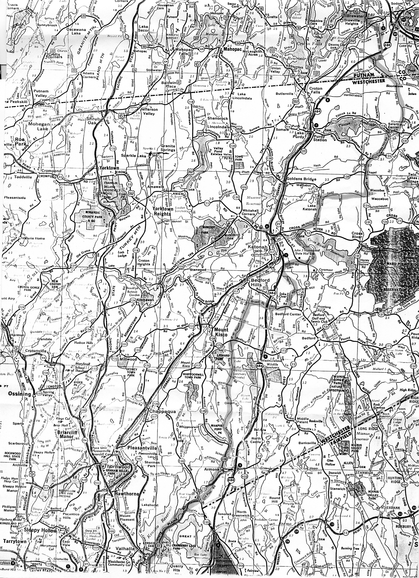
Route from North White Plains to Brewster

